HOTEL MANAGEMENT SYSTEM

END TERM REPORT

*by*

Name: Vivek Kumar Sahu Name: Kirti Gaurav Mishra

Reg No: 11918241 Reg No: 11905578

Roll No: 21 Roll No: 22

Section: K19HV Section: K19HV

Name: Rohan Shahani Name: Yash Shedpure

Reg No: 11906399 Reg No: 11904152

Roll No:23 Roll No: 24

Section: K19HV Section: K19HV

**

Department of Intelligent Systems

School of Computer Science Engineering

Lovely Professional University, Jalandhar

*12-04-2020*

Student Declaration

This is to declare that this report has been written by me/us. No part of the report is copied from other sources. All information included from other sources have been duly acknowledged. I/We aver that if any part of the report is found to be copied, I/we are shall take full responsibility for it.

Name: Vivek Kumar Sahu Name: Kirti Gaurav Mishra

Reg No: 11918241 Reg No: 11905578

Roll No: 21 Roll No: 22

Section: K19HV Section: K19HV

Name: Rohan Shahani Name: Yash Shedpure

Reg No: 11906399 Reg No: 11904152

Roll No:23 Roll No: 24

Section: K19HV Section: K19HV

Date: 12-04-2020

TABLE OF CONTENTS

TITLE

1. Background and objectives of project assigned
   1. An Introductory description
   2. Motivation and outcome of project
   3. Goals and Objectives
2. Description of project
3. Work Distribution
4. Implementation of scheduled work of Project
5. Technologies used

AN INTRODUCTORY DESCRIPTION

Billing

A **hotel management**  is a **system** that simplifies a **hotel's** operations by automating them. It covers minor to major aspects of **hotel management** viz. reservations, front-office, back-office, housekeeping, maintenance, guest **management** and even billing.

The project, Hotel Management System is a website that allows the hotel manager to handle all hotel activities online. Interactive UI and the ability to manage various hotel bookings and rooms make this system very flexible and convenient. Other hotel services can also be viewed by the customers and can book them too. The system is hence useful for both customers and managers to portable manage the hotel activities.

MOTIVATION AND OUTCOME OF PROJECT

Following are the outcomes of this project:

1. Helps to facilitates a **hotel's** reservation **management** and administrative tasks.
2. Helps users to book and view different hotels
3. Shows various restaurant to users depending on their choice
4. Give information of contact person of the required hostel.

GOALS AND OBJECTIVES

* Provide people seeking hotel rooms with accurate information about available accommodations.
* Allow booking of rooms without errors and without creating conflicts.
* To present the hotel as an excellent, or the best, choice to its target market.
* To make it easy for customers to make reservations.
* To make it easy for customers to get their questions answered, lowering barriers to selecting this chain's hotels.

PROJECT DESCRIPTION

As the name recommends, the Online Hotel Management System permits the clients globally to reserve the rooms in the hotel at any time. It will provide a unique search and book functionally for the customers anywhere in the world. This project can be used by the clients and the travel agencies who will help them to reserve the hotel of their choice. Sometimes people face problem in reserving the hotels in the places where they want to visit. In that situation, this project can be of great relief to them. The user interface must be simple and easy to understand even by the common man.

The Central objective of the Hotel Management System project is to provide the information about the hotel as well as online facility for booking rooms. In existing system (i.e. Manual System), person has to go to the Hotel for booking, enquiry etc or another option is telephone booking. But user can’t get detailed information about the hotel the proposed web based system automates it easier for a person to sit at home and book rooms in a hotel. As well as this software system allows administrator to maintain a database for adding a new employee detail, daily attendance and salary calculation of the employee, and also administrator has an ability to view and modify the database content from anywhere at any time.

WORK DISTRIBUTION

1. Vivek Kumar Sahoo (11918241):-Creating and managing of login details of the hotels such as add and edit employees, salary of employees and attendance of employees & and Creating About page of hotel.

2. Kirti Gaurav Mishra (11905578):-Creating Login page which includes login id and user name and cancel button with Hompage design & creating restaurant page that includes food menus and lastly payment page integeration.

3. Rohan Shahani(11906399):-Creating graphics and webpage designing for the entire project.

4. Yash Shedpure(11904152):- Creating booking webpage for details of the customer such as name, Email, Room type, Mobile No to book a room in a hotel or reset the data .

IMPLEMENTATION OF SCHEDULED WORK OF PROJECT

Hotel needs to maintain the record of guests and reserve rooms beforehand. Customers should be able to know the availability of the rooms on a particular date. They should be able to reserve the available rooms according to their need in advance. To make their stay comfortable, they are provided with food and other services. The record of the food taken by each customer and the services availed by the customer should be kept. These records help in generating bill.

The various options available inside the system are as follows:

* Home
* Booking
* Restaurant
* Contact us
* Login

Home

After clicking the home button, a new webpage opens which gives the information about the given hotel.

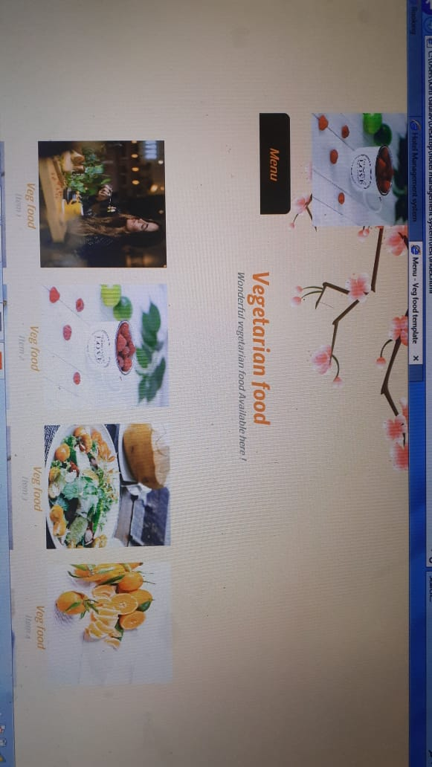

Booking

Under this webpage different options appears which includes information neesds to be filled which are as follows:

* Name
* Email
* Mobile No
* Check in
* Check out
* Room Type

There are also two buttons book to book the information of the customer and reset and empty all the boxes.

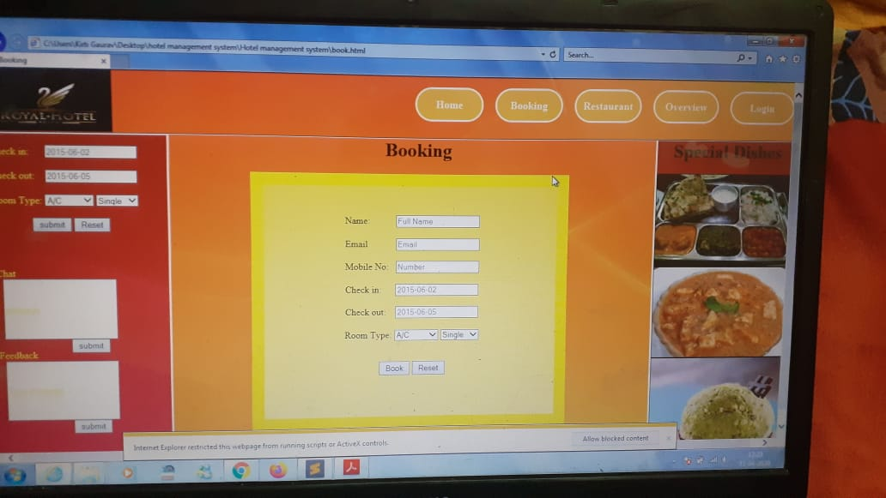

Restaurant

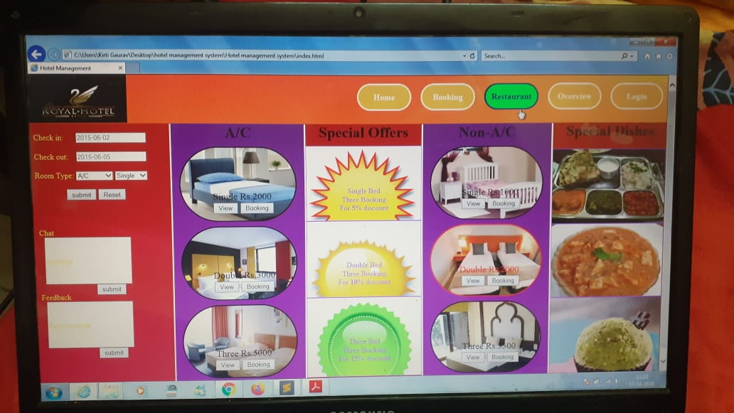

Contact us

Gives the information of required person of the hotel to be contacted

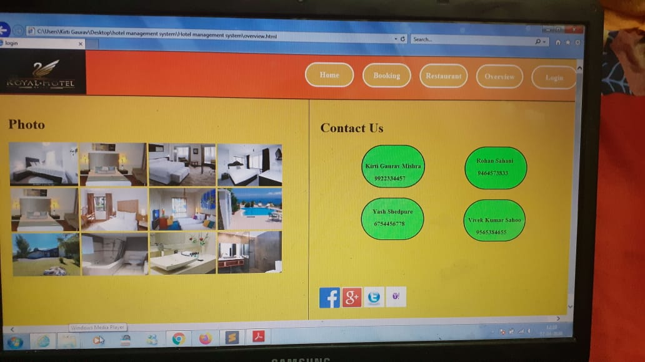

Login

This webpage asks user to enter room no and room id to login and a cancel option as yes and no.

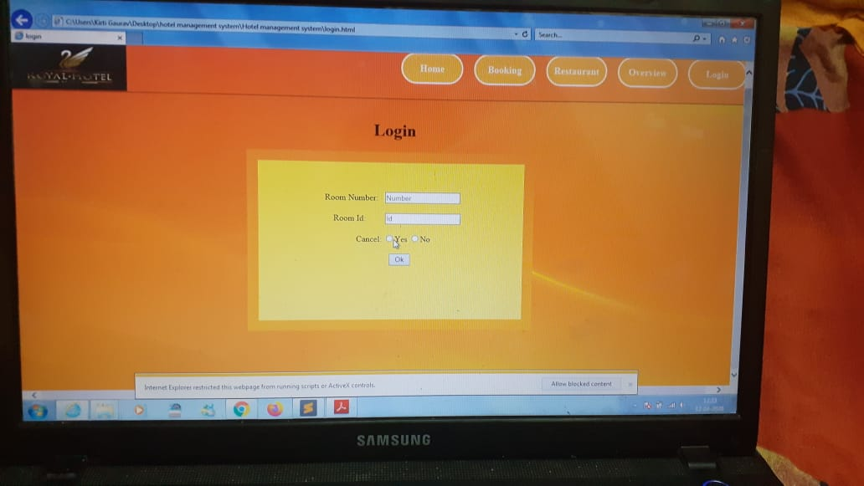

Technologies used:

Html, CSS and Java Script has been used to design this system. Moreover it is uploaded on github.